In your small groups:
Siobhan: Whoever’s name is first alphabetically
Tutor: Whoever’s name is second alphabetically
PT: Whoever’s name is third alphabetically
Observers: Everyone else.

The Action Plan & Progress on it
Action | Progress
Increase Theory
- Siobhan will self-research theory for 3 hours per week. | Started well, no theory reading done in last 3 weeks
- Siobhan will bring one theory to each supervision and be able to discuss relevance in practice | None provided in supervision for the last 3 weeks
- Tutor will provide a list of theory books which Siobhan can use to direct her research. | Provided by email on 12/03/20
Discussing Theory under a level of pressure
- Siobhan will take one hour before each supervision to bullet point out her discussion points instead of reading from a prepared essay. | Not completed in last 3 weeks
- The PT will continue to provide weekly supervision to support Siobhan to have opportunity to evidence theory to practice knowledge. | Ongoing
Managing Time
- The PT will support Siobhan to plan her diary so time to write up notes, support plans and complete reports are scheduled into it. | Completed weekly in supervision – Siobhan now able to do this independently

Restorative Frame and Questions
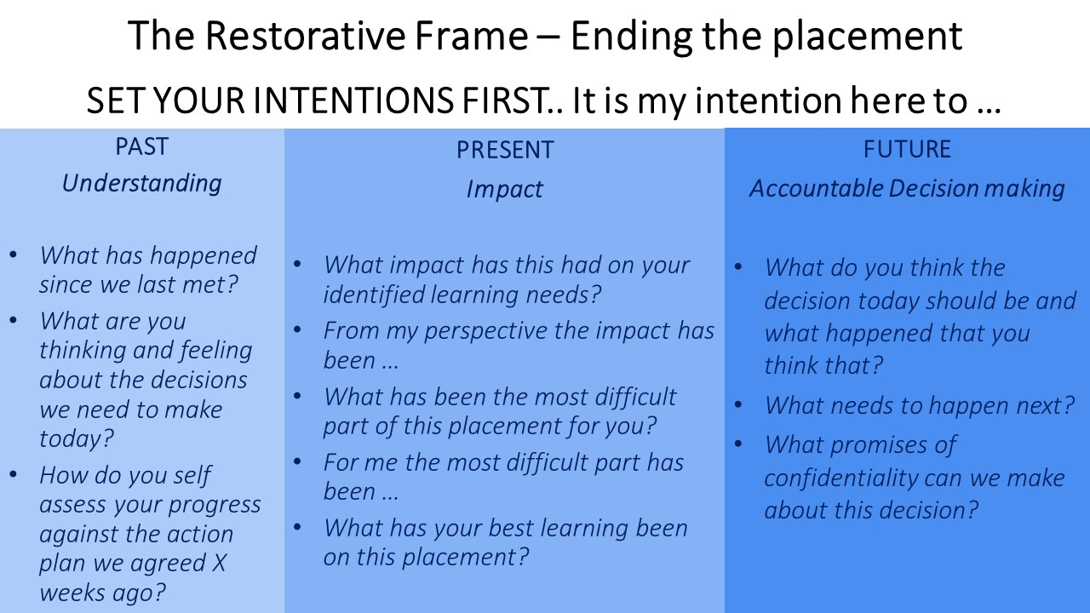

Questions for the Observers to think about.
- Did the PT set out an intention and did you feel the intention softened the emotive meeting subject?

- Did the meeting feel objective or was there a sense of shaming or blaming in the meeting? What made you think this?

- Could you see the frame of Understanding The Past, Impact on the Present, and Future Accountability in the meeting?

- Was there clarity about the decision to end the placement and was the evidence for the decision accounted for? What makes you think this?

- Do you think the PT managed to deliver difficult news whilst maintaining compassion and respect for Siobhan as a human being? What made you think this?

- How do you think this will have felt for Siobhan?

- How likely do you think Siobhan is to
  - Make a complaint about this placement
  - Have a dip in her mental health because of this meeting
  - Undertake further adult learning in some profession after this placement

